**MICROSERVICES CASE STUDY**

1. **Create two microservices book-service and subscription-service.**

Used MySQL DB to develop the application.

Book-service:

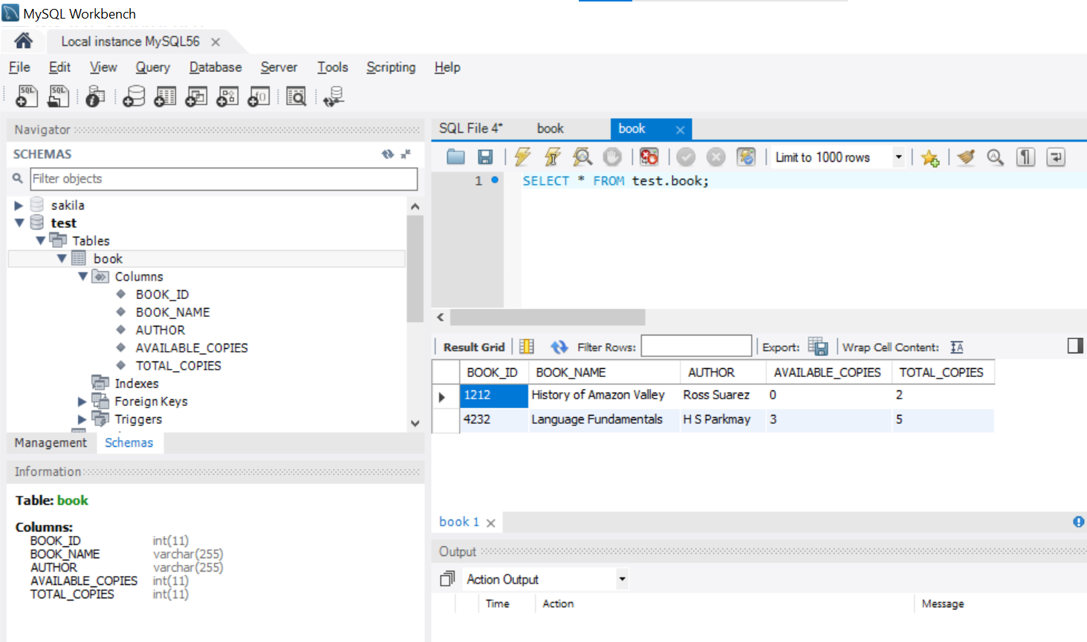

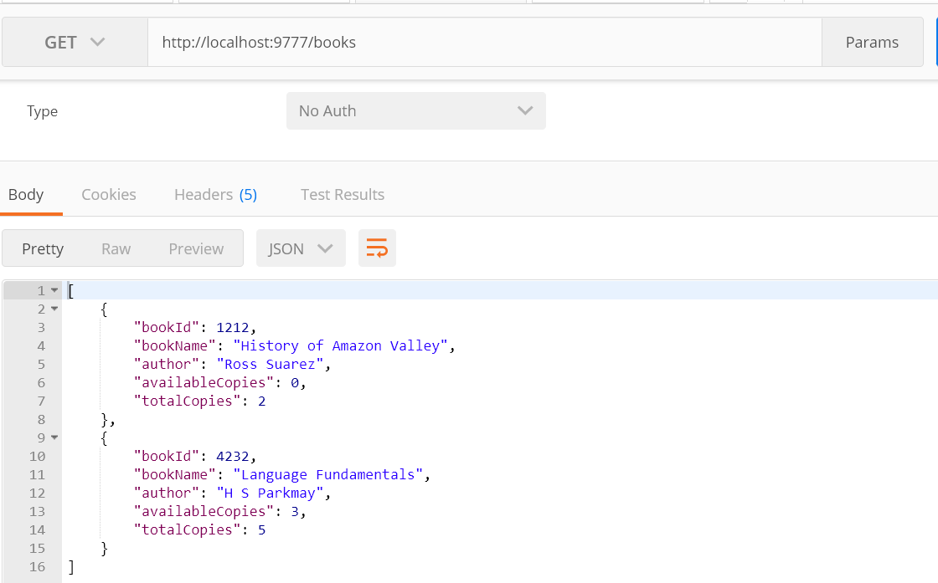

Subscription-service:

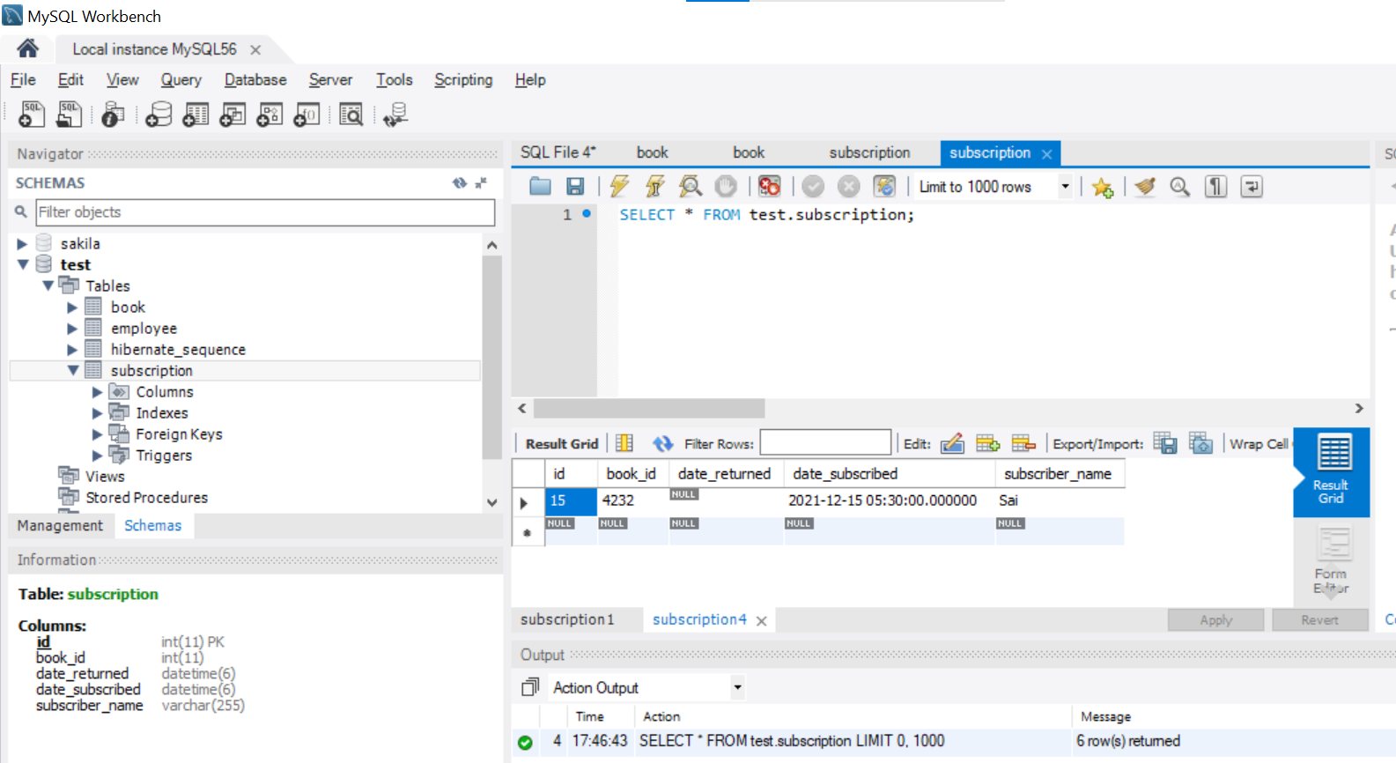

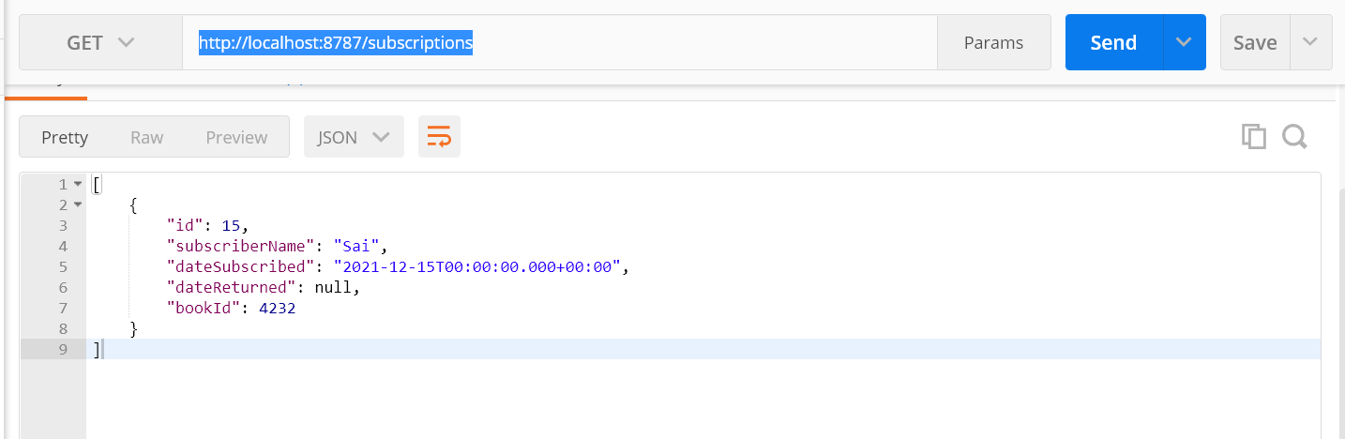

1. **Used Feign Client to interact the book-service from Subscription-service.**

As per table data, no books available for BOOK_ID=1212. If u try to subscribe. It should not allow.

If no copies available then, retuning the HTTP status code as 422- UnProcessable Entity.

If copies are available then, returning the HTTP status code as 201 -created.

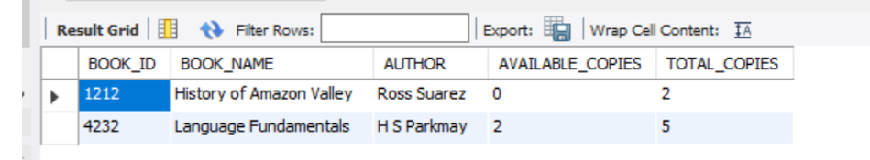

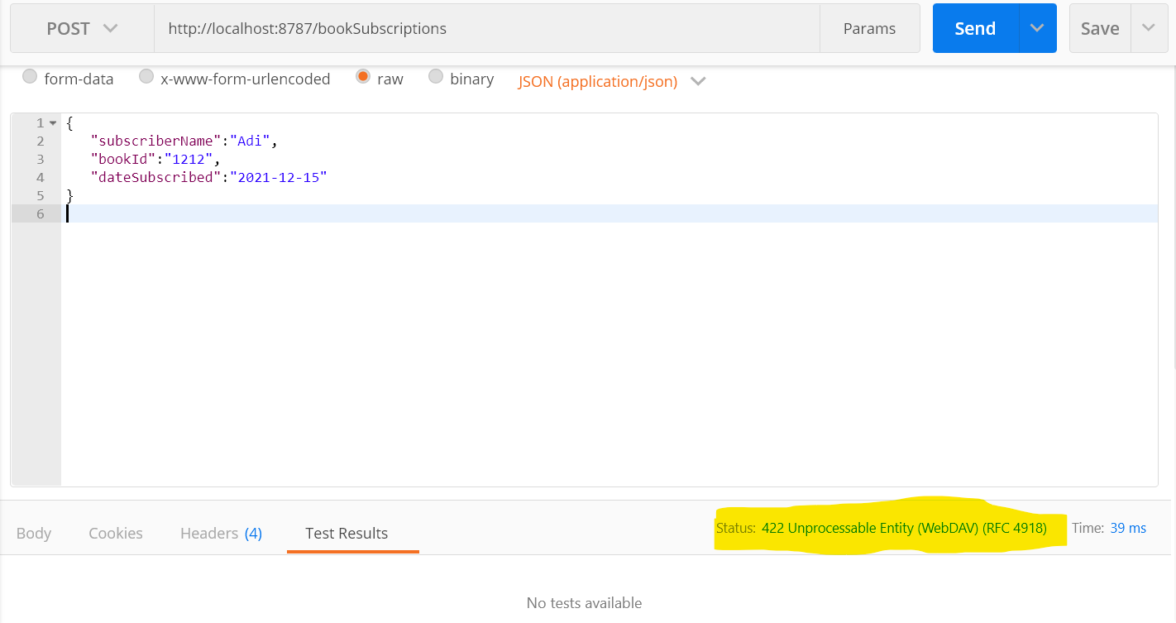

For BOOK_ID 4232, ‘2’ copies are available. So, it should allow to subscribe.

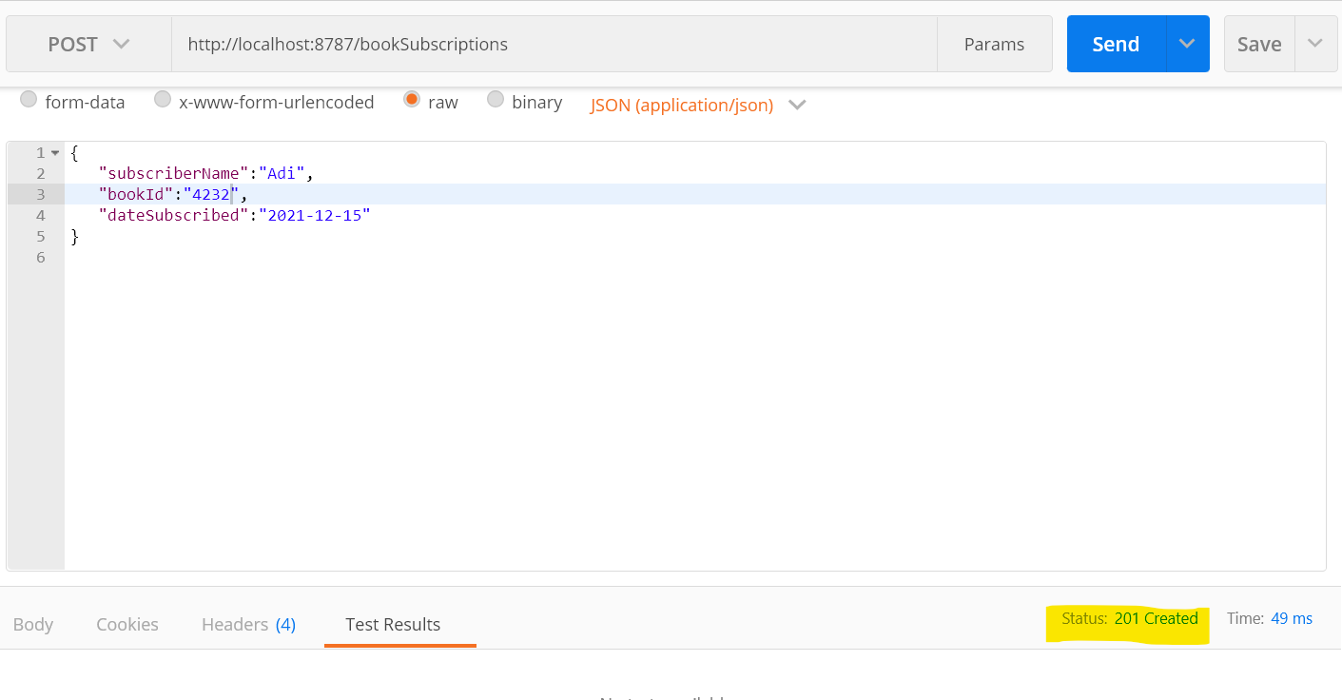

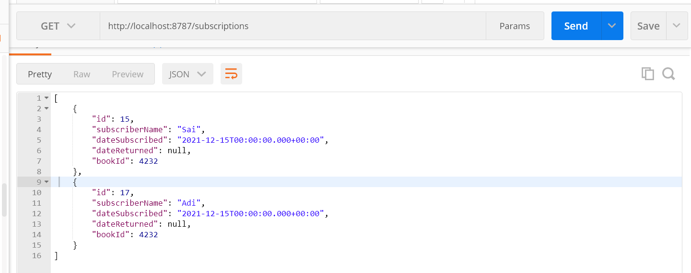

1. **Use a @Transactional annotation to try the spring managed Commit/Rollback transaction management feature.**

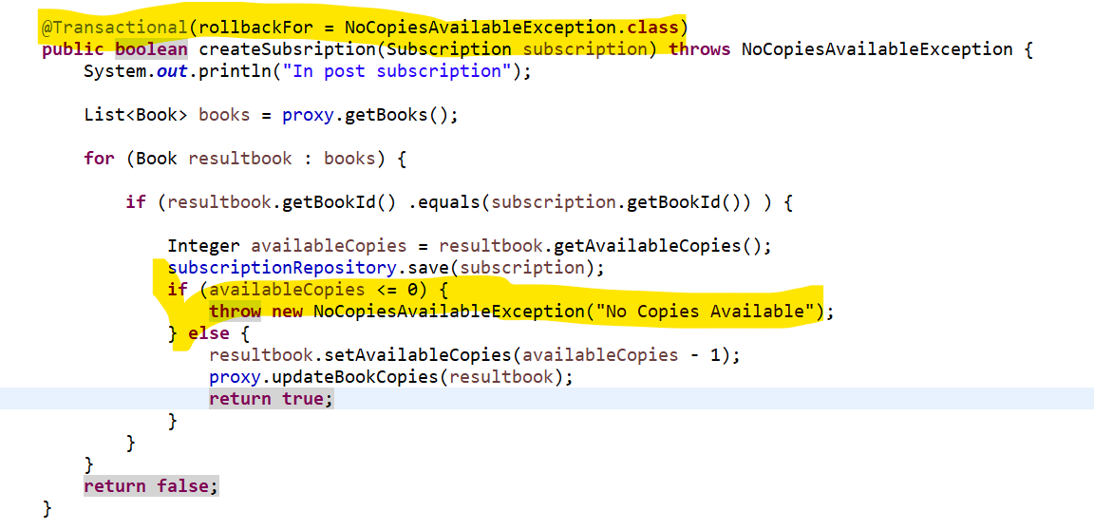

1. **Used Eureka server to register and discovery.**

